

# CAP777 – WEB DEVELOPMENT USING PHP

CA - 4

**(Yoga Registration website)**

Submitted by

# (Ankit Kumar Soni) – (12113094)

# (Ankit Kumar Mishra) – (12113075)

**School of Computer Application Lovely Professional University, Phagwara**

**Acknowledgment**

The Project I had under the STAR COURSE – CAP777 (WEB DEVELOPMENT USING PHP) was a great chance for learning and professional development. Therefore, I consider myself as a very lucky individual as I was provided with an opportunity to be a part of it.

I express my deepest thanks to my course instructor Mr. Mukesh Kumar (Assistant Professor) SCA, LPU for allowing me to grab this opportunity. I choose this moment to acknowledge his contribution gratefully by giving necessary advice and guidance to make my internship a good learning experience.

**[Ankit Kumar Soni] [12113094]**

**[Ankit Kumar Mishra] [12113075]**

**Table of contents**

|  |  |  |
| --- | --- | --- |
| Sr. No. | Description | Page No. |
| 1 | Introduction to the Project |  |
| 2 | Scope of the Project |  |
| 3 | Modules/ Functionalities of the Project |  |
| 4 | Roles of individuals in the Project |  |
| 5 | Structure of the Back End (Database & Tables) |  |
| 6 | Structure of the Front End (User Interfaces) |  |
| 7 | Site Map or Navigation Structure |  |
| 8 | Code snippets |  |
| 9 | Bibliography or References |  |

**Introduction to the Project**

The Yoga Registration website is a platform for people to find and register for yoga events happening in their area. The website offers a variety of features that allow users to search for events by keyword, location, or date. Users can also create and manage their own events.

This website is designed for people to register for cultural events.

This website will allow users to find events by notification, which is uploaded by admin, and find date when event has been happen. Users will also be able to contact to admin an account, which will allow them to contact and ask query regarding events and receive solution regarding query for event.

**Scope of the Project**

The project aims to create a website where users can enter events and information about them. The information will be stored in the database and the visitors of the website will be able to search for events and view the details.

We have created a registration website for cultural events. From the admin panel, users can add events and information about them. The information will be stored in the database and the visitors of the website will be able to search for events and view the details.

Scope of the project:

* We can use this project for yoga event which is happen in universities.
* We can use this project for yoga event which is happen in Government offices.
* We can use this project for yoga event which is happen in offices.

Features of the website:

* Admin can add yoga events and information about them.
* The information will be stored in the database.
* Users can find notification for events and view the details.
* User can easily contact to the admin through contact us form.
* User can easily ask his query regarding events.
* Admin can easily update notification regarding events.

**Modules/ Functionalities of the Project**

**Admin Register and login:**

In this module admin can easily register himself, after registering admin has been able to login for admin panel.

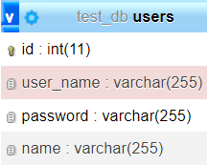

**event Registration:**

In this module students will be able to register himself by registration page which is visible in front of the website.

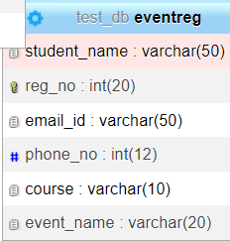

**Contact us:**

In this module students will be able to contact to admin by filling contact us page which is visible in front of the website.

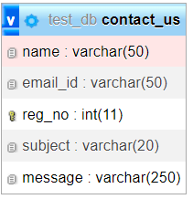

**Notification:**

In this module admin will be send notification to students regarding which is visible in admin panel of the website.

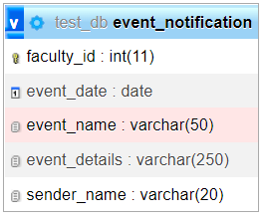

**Roles of individuals in the Project**

(Ankit Kumar soni) [reg no: 12113094]

Backend, frontend, and database.

(Ankit Kumar Mishra) [reg no: 12113075]

Backend, frontend, and validation.

**Structure of the Back End (Database & Tables)**

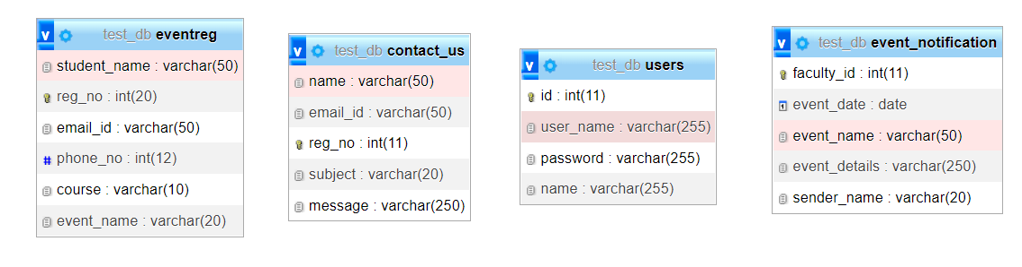

**Structure of the Front End (User Interfaces)**

**Index Page**

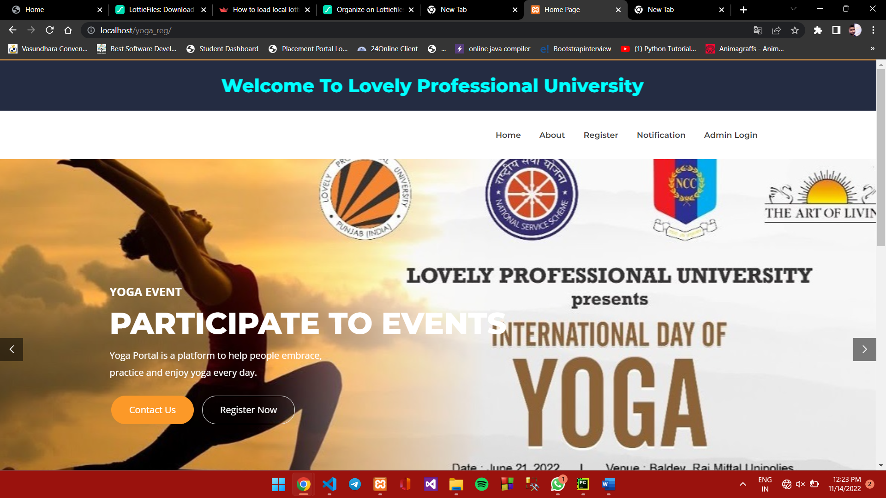

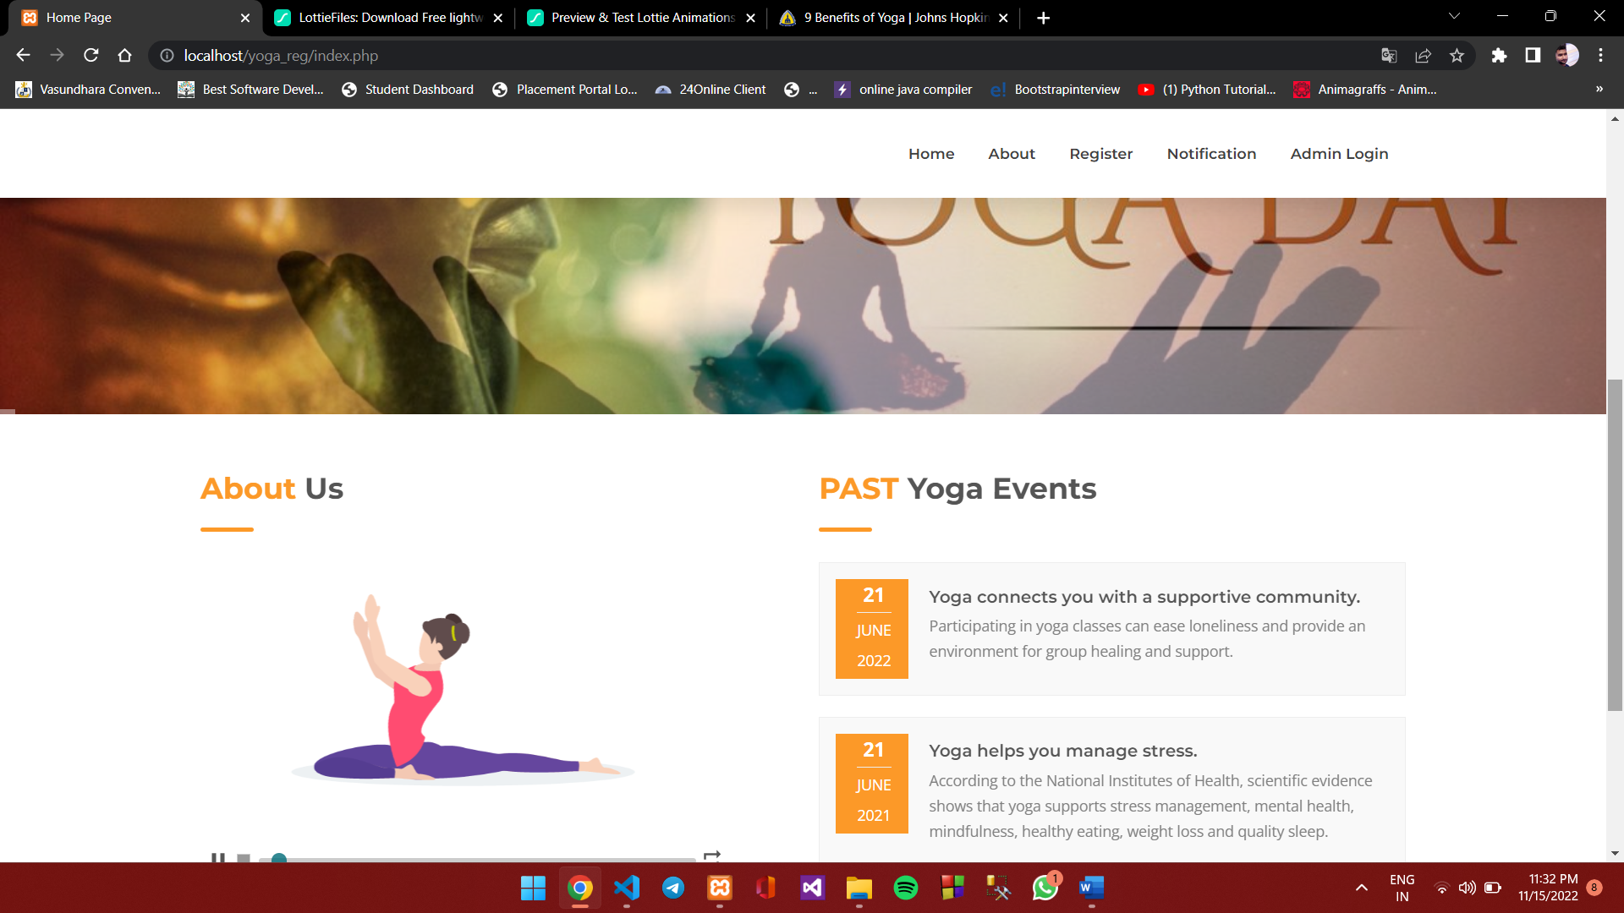

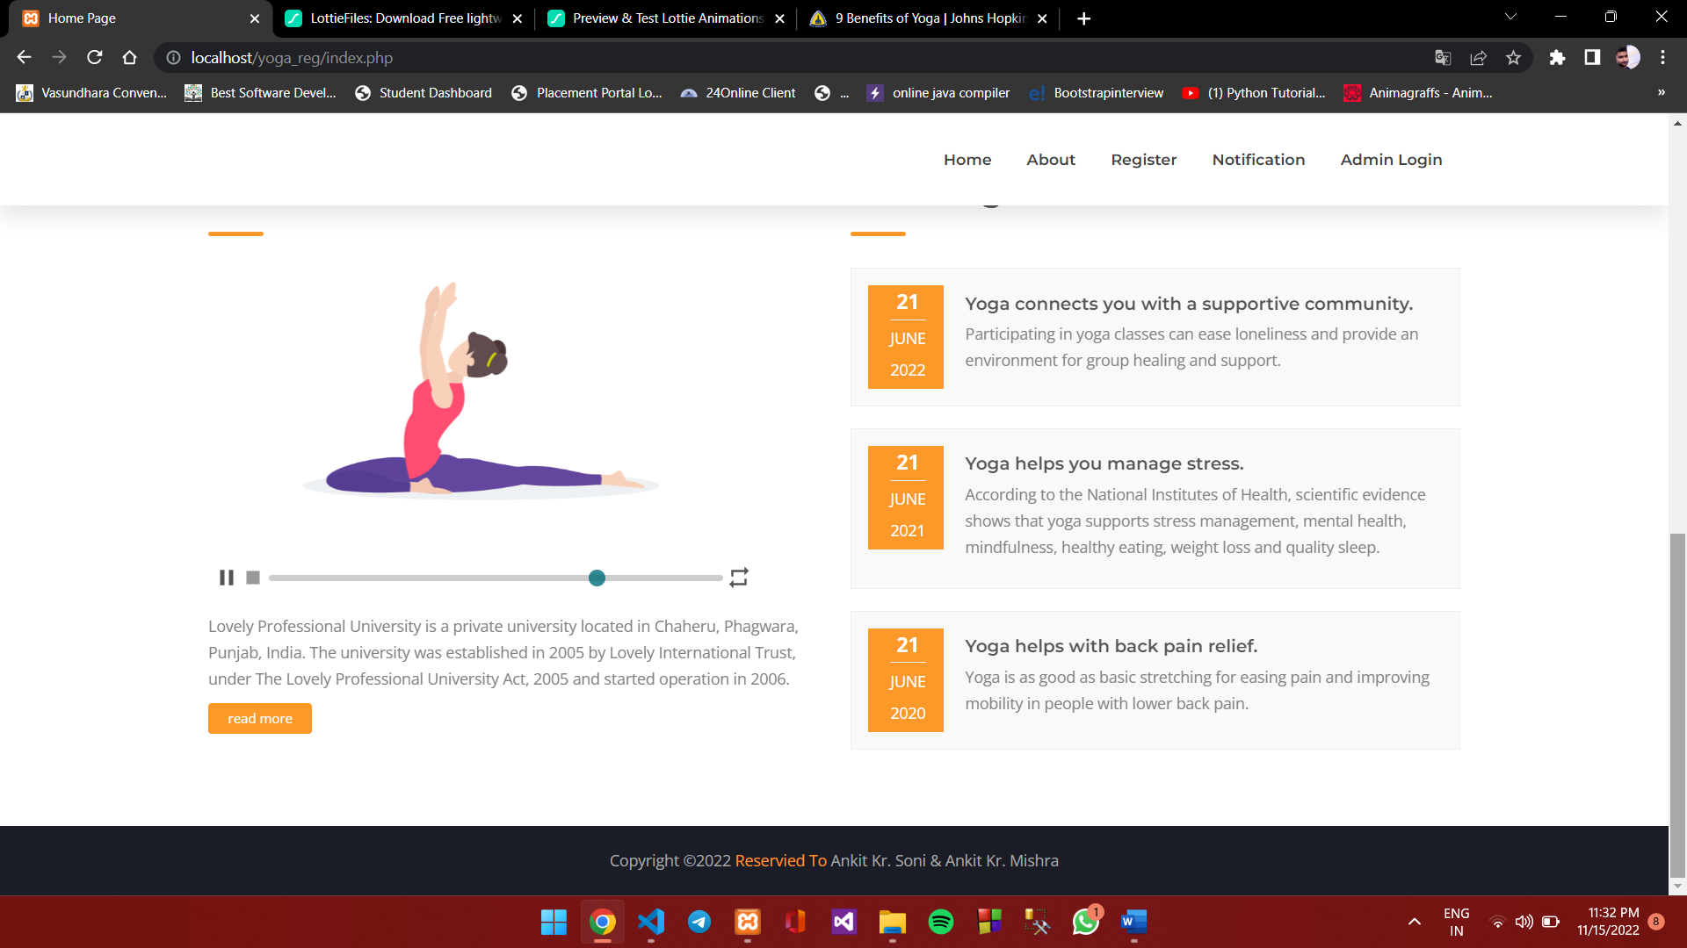

**About us**

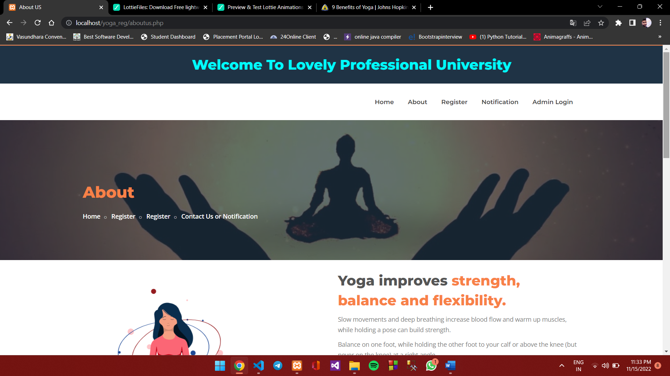

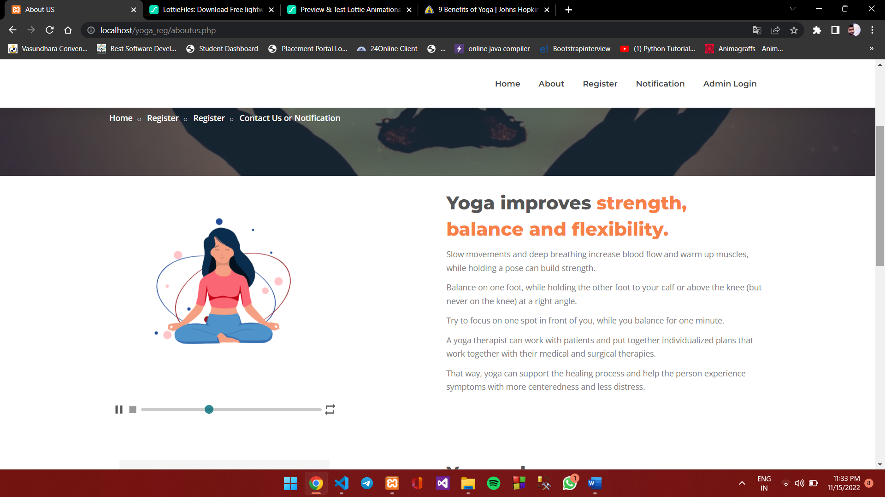

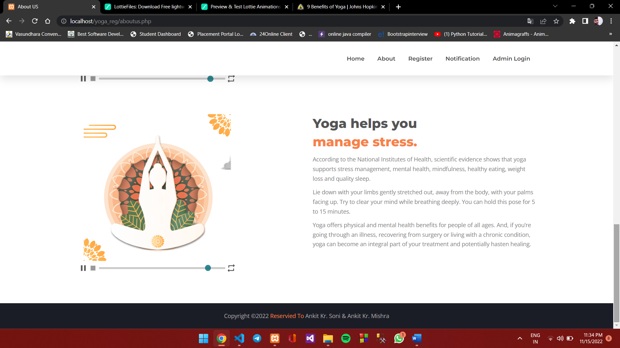

**Register**

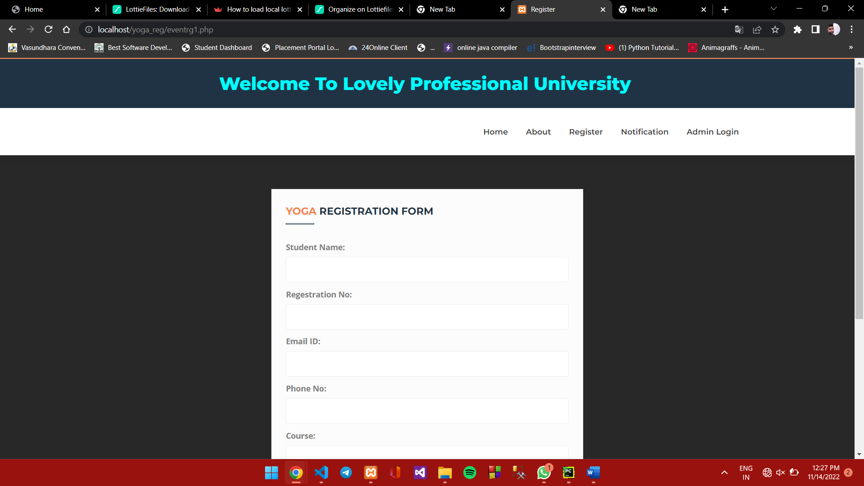

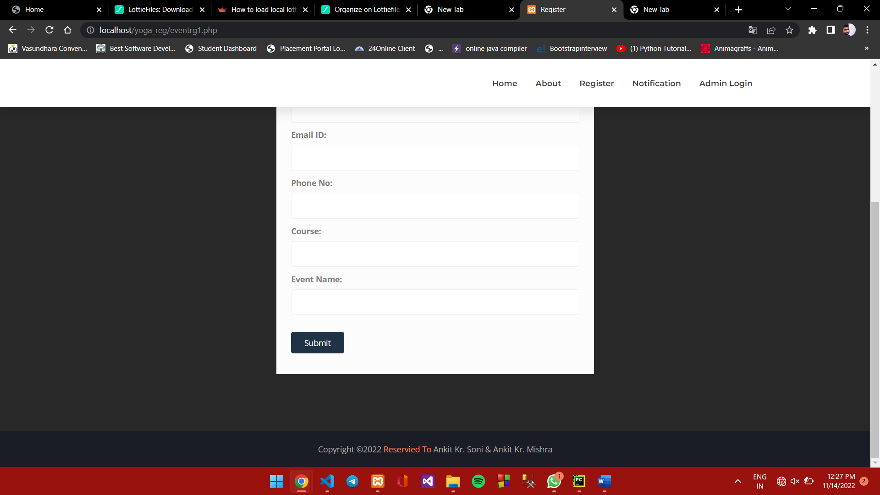

**Event Notification & Contact us**

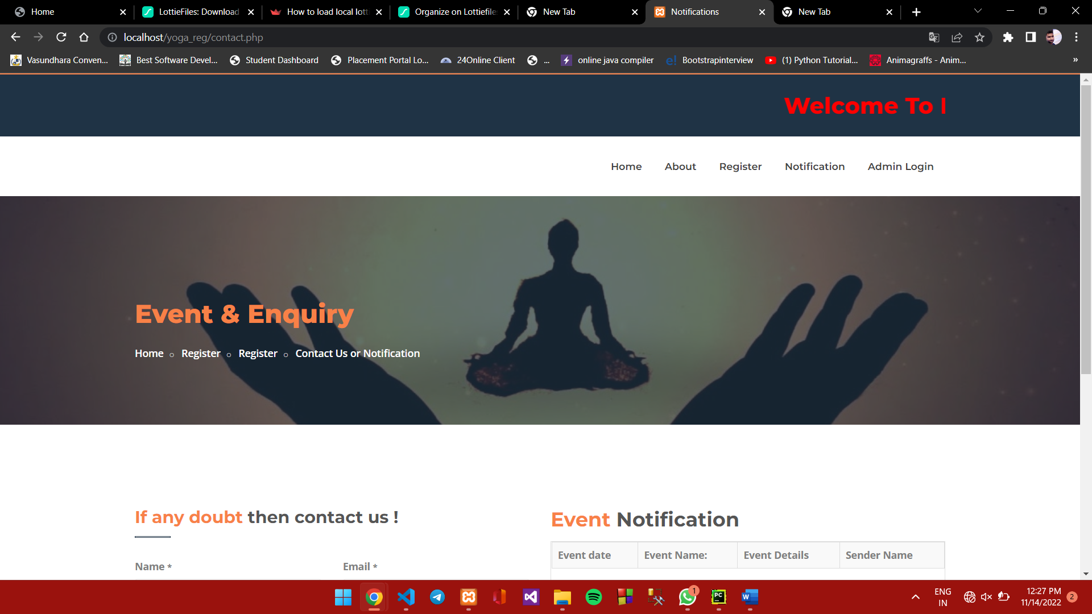

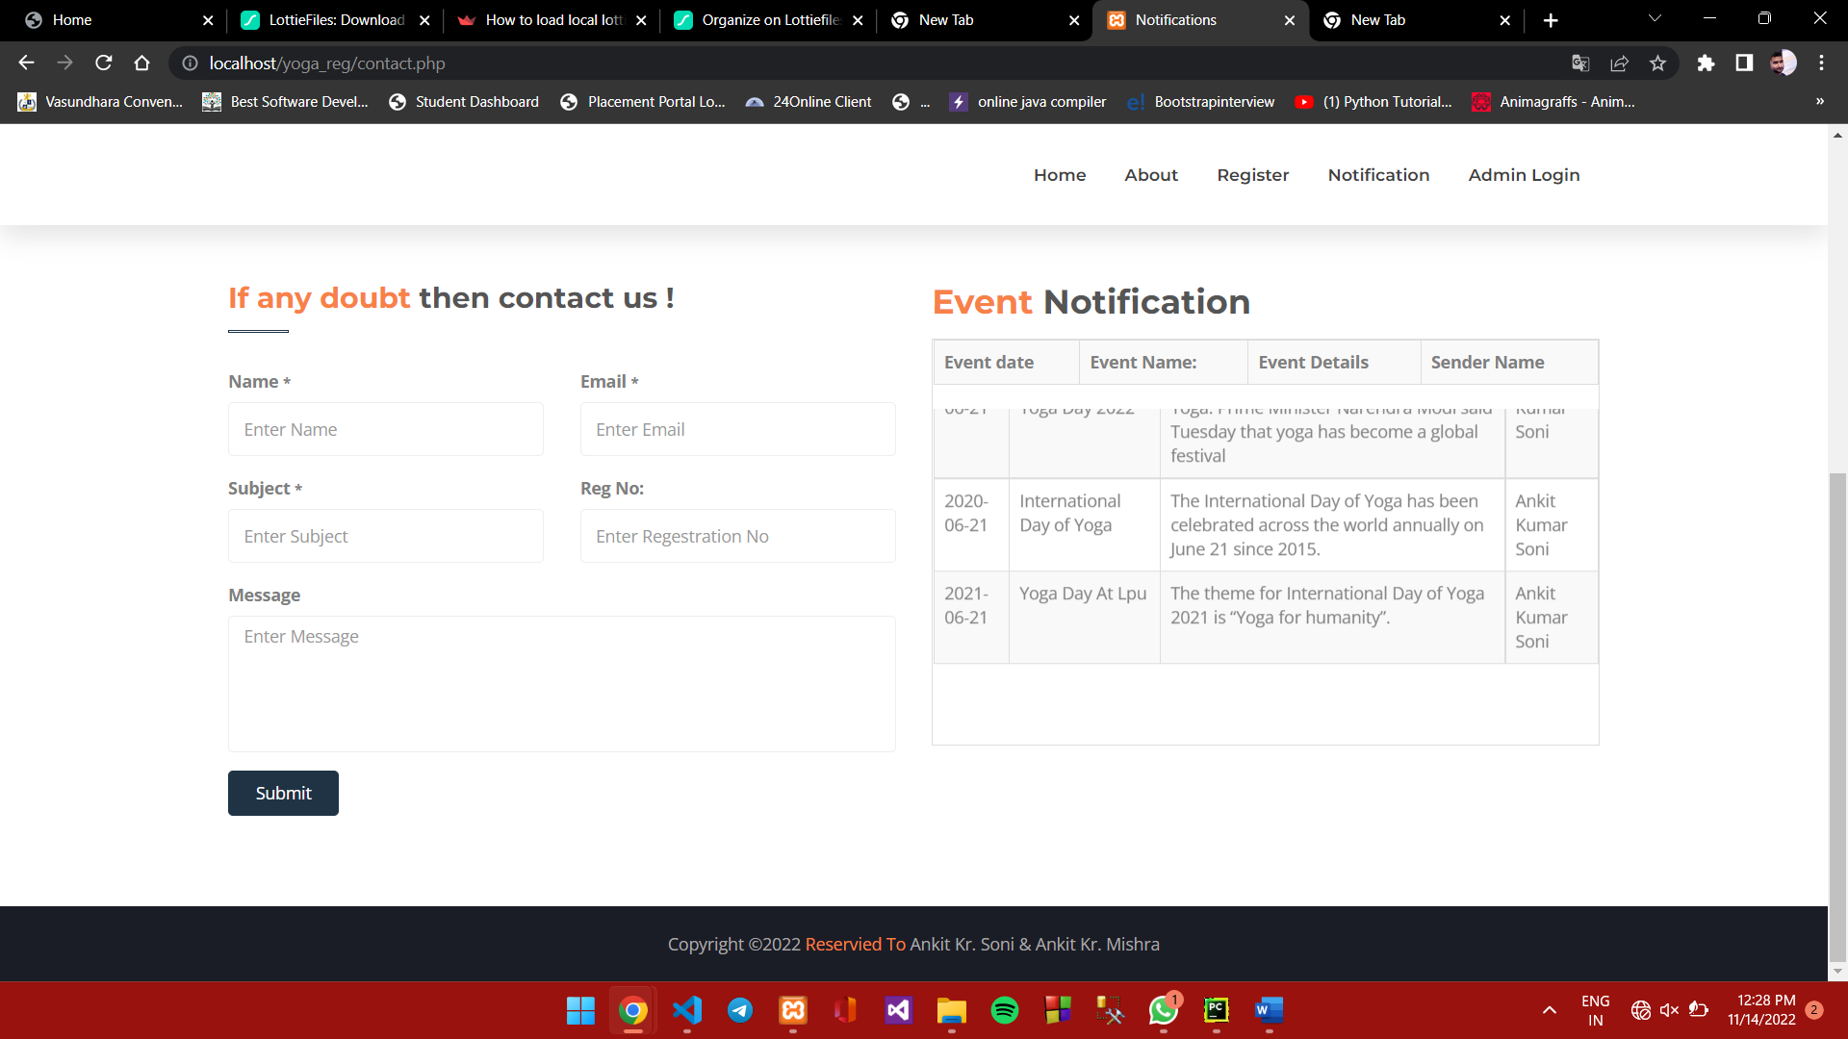

**Login page**

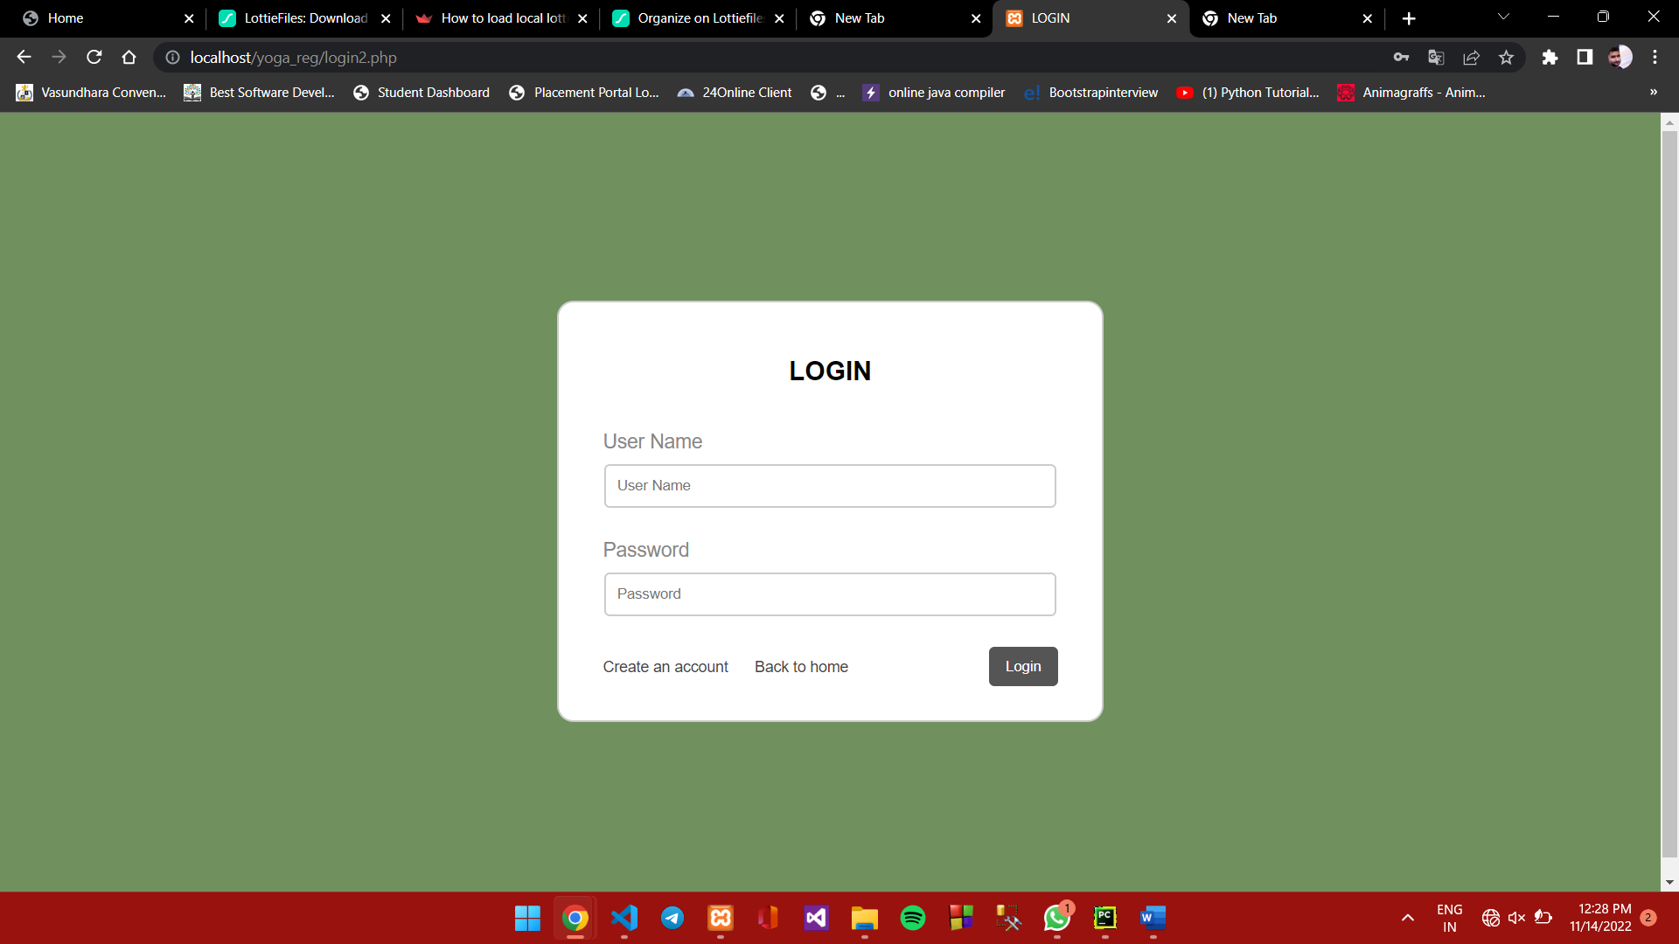

**Create admin page**

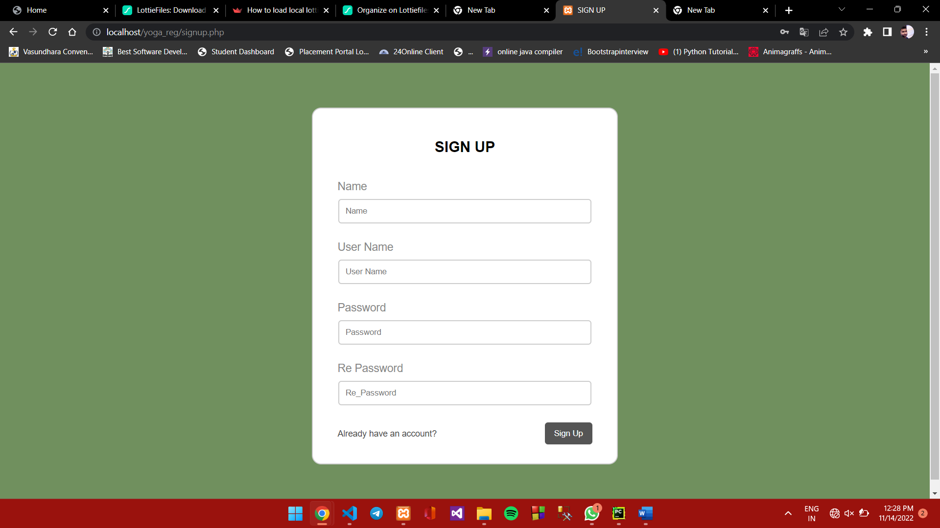

**Admin panel for registered student data view page**

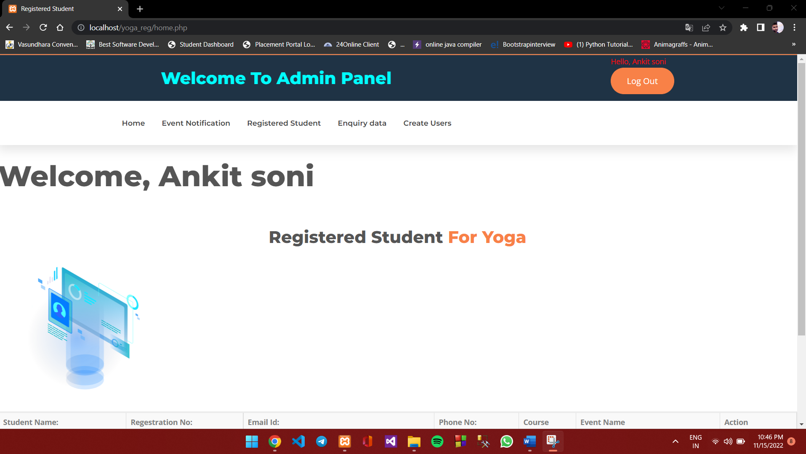

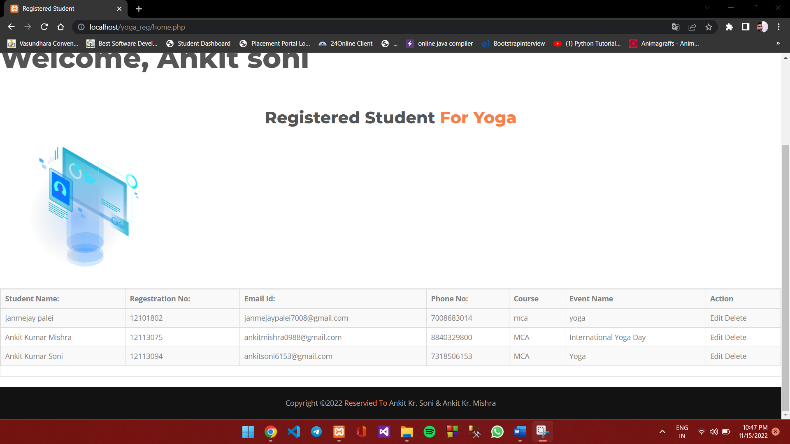

**Admin panel for Add Notification and view notification Page**

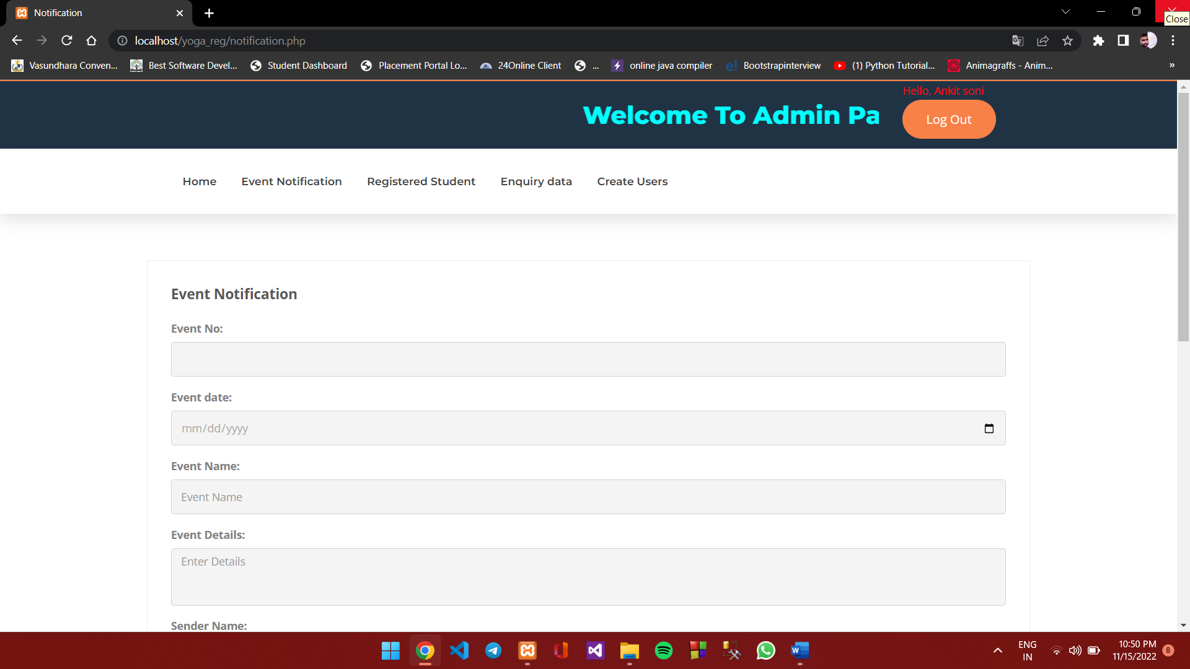

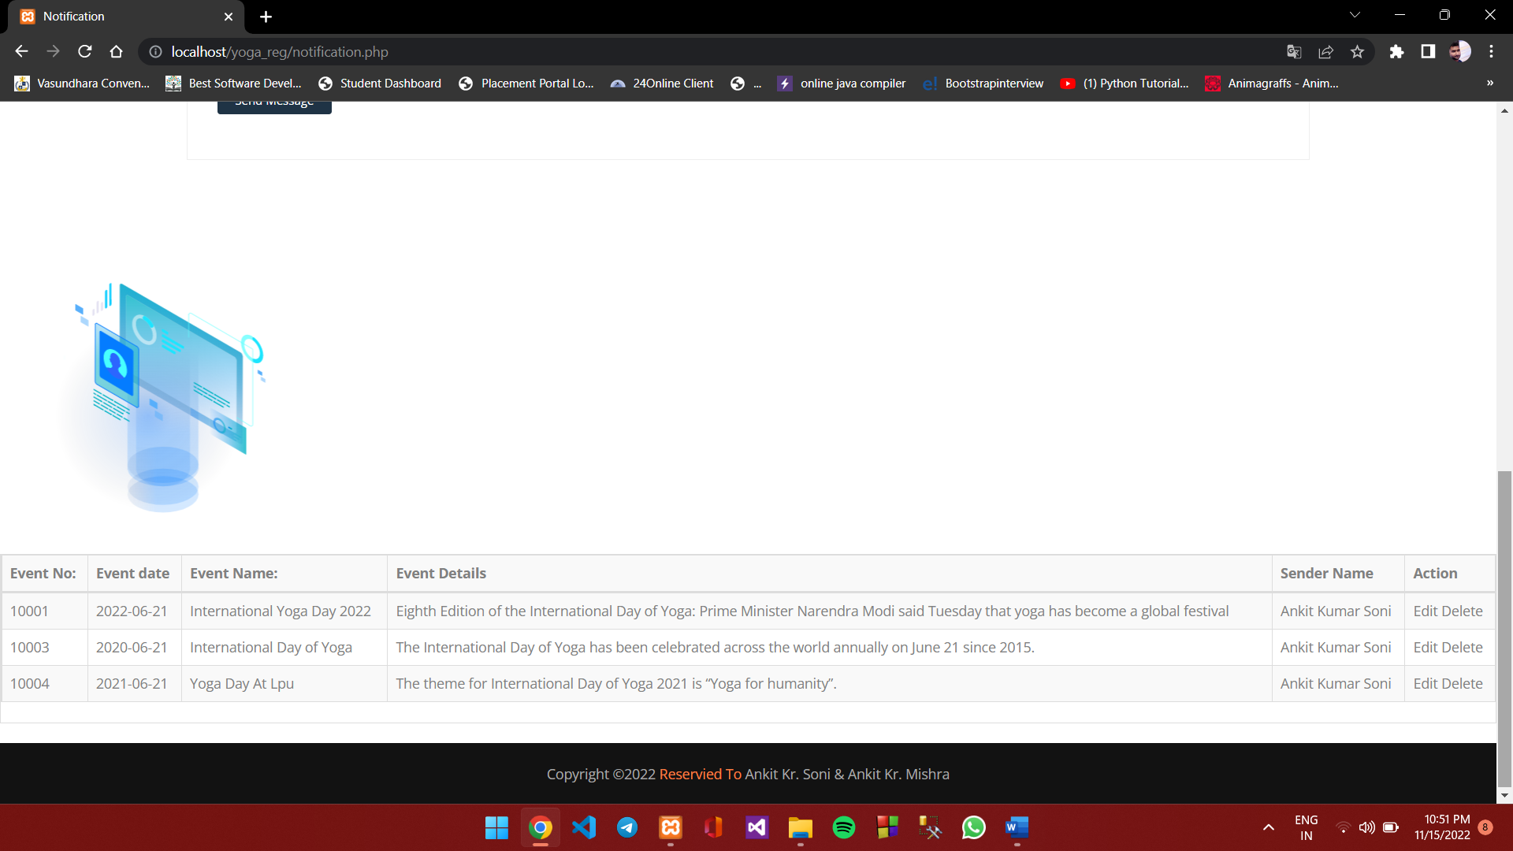

**Admin panel for view enquiry which is raised by student Page**

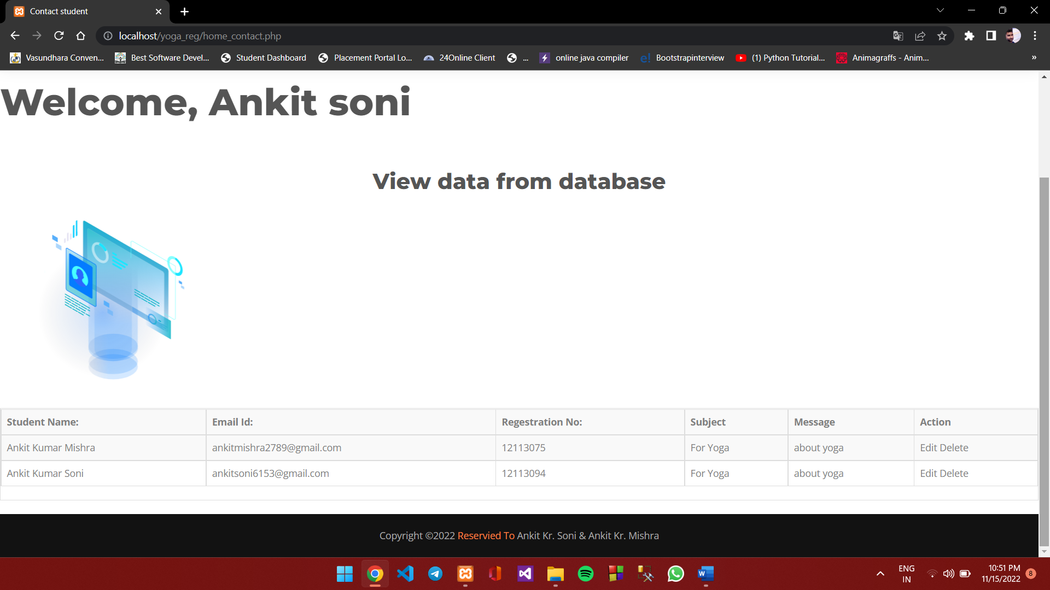

**Code snippets**

Login code

<!DOCTYPE html>

<html>

<head>

<title>LOGIN</title>

<link rel="stylesheet" type="text/css" href="style.css">

</head>

<body style="background-color:#70905e;">

<form action="login.php" method="post">

<h2>LOGIN</h2>

<?php if (isset($_GET['error'])) { ?>

<p class="error"><?php echo $_GET['error']; ?></p>

<?php } ?>

<label>User Name</label>

<input type="text" name="uname" placeholder="User Name"><br>

<label>Password</label>

<input type="password" name="password" placeholder="Password"><br>

<button type="submit">Login</button>

<a href="signup.php" class="ca">Create an account</a>

<a href="index.php" class="ca">Back to home</a>

</form>

</body>

</html>

**Database connectivity**

Code

<?php

session_start();

include "db_conn.php";

if (isset($_POST['uname']) && isset($_POST['password'])) {

function validate($data){

$data = trim($data);

$data = stripslashes($data);

$data = htmlspecialchars($data);

return $data;

}

$uname = validate($_POST['uname']);

$pass = validate($_POST['password']);

if (empty($uname)) {

header("Location: index.php?error=User Name is required");

exit();

}else if(empty($pass)){

header("Location: index.php?error=Password is required");

exit();

}else{

// hashing the password

$pass = md5($pass);

$sql = "SELECT * FROM users WHERE user_name='$uname' AND password='$pass'";

$result = mysqli_query($conn, $sql);

if (mysqli_num_rows($result) === 1) {

$row = mysqli_fetch_assoc($result);

if ($row['user_name'] === $uname && $row['password'] === $pass) {

$_SESSION['user_name'] = $row['user_name'];

$_SESSION['name'] = $row['name'];

$_SESSION['id'] = $row['id'];

header("Location: home.php");

exit();

}else{

header("Location: index.php?error=Incorect User name or password");

exit();

}

}else{

header("Location: index.php?error=Incorect User name or password");

exit();

}

}

}else{

header("Location: admin1.php");

exit();

}

**Bibliography or References**

**Database connection.**

” <https://stackoverflow.com/questions/55143102/how-to-connect-to-mysql-database-in-php>”

**Frontend design:**

“ <https://getbootstrap.com/docs/4.6/getting-started/introduction/>”

**Validation:**

“ <https://www.w3schools.com/Php/php_form_validation.asp>”

Etc.